**1 INTRODUCTION:**

* + - Preliminary means something that comes before something else.
    - Denoting an action or event proceeding on in preparation for something more important designed to orient or Proceeding acquaint with a situation before proceeding.
    - Now a day’s video-game industry is one of the biggest and fastest growing around providing Jobs to many people and having a very big market.
    - From the 1950s until now many different video game genres were created suiting different people tastes.
    - Among them, shoot those up games mainly consist of player trying to complete the game while evading different obstacles which can include enemies, environment objects, or different types of projects.
    - In game project the product is game, but and here comes the point: A game is much more than just its software.
    - The software part of the project is not the only one, and it must be considered in connection to all other parts: the environment of the game the story characters, game plays, the artwork and so on.

**1.1: PROJECT SUMMARY:**

* The space war is a very attractive game for any ages people.
* The spaceship moves in the space and protect themselves from various enemies.
* Enemies attack the spaceship, the spaceship shoots and destroy his enemies.
* The score are being increased automatically by destroying each enemies.
* The player starts the game with three lives, and has to constantly shoot and dodge to save themselves from being wiped out by constant oncoming barrage of attacks!
* A hit from an enemies causes the players health to decrease.
* This game also features of power-ups which boosts player's defence by replenishing your health.
* As a player's score increases the game bumps up the difficulty by increasing the frequency of the enemies attacks.
* There by ensuring the player stay engaged and alert.
* The player can play the game using only keyboard bindings (Left Arrow key to move left, Right Arrow key to move right, space bar to shoot Laser, our Escape key to move on the Pause menu).
* There will be random number of enemy and space ship each time game will start and they will appear in center bottom location the in screen.
* Player have four Menu on the main screen from where player control game can start the game, control game audio sound and can quit the game and there will be a menu where user can find details about developers of the game.
* In pause menu user will get three options first one is to resume game, second option is control options where user can turn on or off our game background audio and third option is Back to menu where user will redirect to the main screen.
* When user start the game firstly they will show the first scene 1 of the game where they will see the script of the game.
* The game will automatically ends when user loss their three lives.

**1.2:** **PURPOSE: GOALS & OBJECTIVES:**

* A space war game, like any other game aims to provide entertainment and challenge to players.
* However it can also serve broader purposes, such education and skill development.
* Here are some of the core goals and objectives of a space wars game:
* **Core Goals:**
* **Player Engagement:**
  + Immersive Experience: create a realistic and immersive space environment.
  + Compelling Game play: Design engaging and challenging game play mechanics.
  + Strategic Depth: Offer opportunities 'for tactical and strategic decision making.
* **Entertainment:**
* Thrilling combat: Provide exciting and intense space battles.
* Satisfying Progression: Reward player skill and effort through progression systems.
* Replay ability: Encourage repeat game play through diverse missions, challenges and modes.
* **Secondary Objectives:**
* **Education:**
* Scientific Accuracy: Incorporate real-world space concepts and technology.
* Historical Accuracy: Reference historical space events and figures.
* Educational content: Provide optional educational materials or mini-games.
* **Skill Development:**
* Problem-solving: Encourage players to think critically and device strategies.
* Spatial Awareness: Improve player's understanding of in space and navigation.
* Hand-Eye Coordination: Enhance player's reflexes and precision.
* **Social Interaction:**
* Multiplayer Modes: Facilitate cooperative and competitive game play
* By effectively balancing these goals and objectives a space war game can captivate players, provide entertainment, and even contribute to Personal development.
  1. **HARDWARE AND SOFTWARE REQUIREMENTS:**
* **Hardware Requirement:**

|  |  |
| --- | --- |
| System Type | 64-bit Operating System |
| Processor | Intel(R) CORE (TM) is-6400 CPU @ 270 GH2 270 GH2 |
| Memory | RAM Min. 2GB or more  and HDD Min. 100MB or more |

* **Software Requirement:**

|  |  |
| --- | --- |
| Platform | Operating System Windows 8 or more |
| Front end | Python any version |
| Editing Tool | IDLE |
| Libraries | Pygame, Random, math |

**2. ANALYSIS:**

* Analysis is the process of considering something carefully or using statistical methods in order to understand it on explain it.
* Analysis is topic the process of breaking a complex substance into smaller parts in order to gain a better understanding of it.
* Analysis is the process of examining something in detail to understand its nature on to determine its essential features.
* Analysis in Project development refers to the systematic examination of a project's various aspects, including its goals, scope, feasibility, risks and required resources to evaluate its potential for success, identify potential problem, and make informed decisions about its execution and direction throughout the project lifecycle.

1. **STUDY OF CURRENT SYSTEM:**

* In the current game the players controls a spaceship, navigating through an enemies and engaging enemy ships.
* The objective is to score points by destroying enemies and surviving as long as possible.
* Power-ups the can be collected to enhance player's ship.
* Key Features:

-2D top-down perspective

-Scrolling background

-Variety of enemy types

-Simple vector graphics

-Core mechanics, ship movement, shooting.

**2.2 PROBLEM AND WEAKNESSES OF CURRENT SYSTEM:**

* **Advantages:**
  1. **Learning Opportunity:**
* Developing a space war game in python provides a great, opportunity to learn and apply fundamental game development concepts, including oop game logic and user input handling.
  1. **Established Player Base:**
* These games already have a dedicated following ensuring a potential Market.
  1. **Proven Game Play Mechanics:**
* Years of refinements have led to polished and engaging game play.
  1. **Strong community:**
* Active communities provide support, feedback and content creation.
  1. **Creativity and Fun:**
* A space war game allows for creative freedom.
  1. **Mature Technology:**
* Established game engines and tools streamline development.
  1. **Expandable and Modifiable:**
* As a beginner or intermediate python developer creating a space war game is a Idea a project because it can easily be expanded.
* **Disadvantages:**

1. **Performance Limitations:**

* Python is not fast as languages like C++ or c#, which are common used for game development.
* This can result in Performance specially when handling complex graphics.
* Large number of moving objects or  advanced physics.

1. **Limited Graphics and visuals:**

* While libraries like Pygame offers basic 2D graphics, they may not be sufficient for high end or 3D space simulations.
* If you want high-quality realistic visuals python and Pygame may fail short requiring you to use  more advanced game engines like Unity or Unreal Engine.

1. **Time consuming for complex project:**

* Developing even a full-fledged space war game even with basic mechanics can be time Consuming, you need to create game assets.(e.g. sprites sound, effects etc...).
* Code the game logic, implement collision detection and test extensively.

1. **Lack of advanced game features:**

* Python and libraries like pygame are not equipped with advanced game development features like networked multiplayer ray tracing or complex physics engines.

1. **Market saturation:**

* The market is already crowded making at harder to stand out.

1. **High Expectations:**

* Players may have high standards due to existing games.

1. **Innovation Challenges:**

* Differentiating from established titles can be difficult.

1. **Limited AI capabilities:**

* AI Programming in python especially in a space war game could be challenging and relatively basic without using dedicated libraries.

1. **Competition from major studios:**

* Large studio may release competing titles with significant resources.

**2.3 Requirements of New System:**

* Proposed system have and advanced visual and 3D graphics engaging interface.
* Proposed system have dynamic gameplay means as players high score increases, the difficulty of the game gradually gets harder.
* While the one type of power-up replenishes player's health, the other increases their firepower.
* Thereby, ensuring that the game remains interesting.
* Complex mechanics game play: small enemies have a lesser toll larger on the player's health bar while larger enemies deal a comparatively heavier damage.
* Proposed game  have engaging background music and sound in the game play that gives realistic experience to the player.
* **Features:**
* Attractive background
* Beautiful Graphics
* Space ship
* Background Music
* Different enemy types
* Live score
* **Advantages :**

**1) Engaging story:**

* Game play have a engaging scripted story into game that will attract the gamer and inspire to play game.

**2) Fresh Perspective:**

* A new game can offer unique ideas and a new features.

**3) Targeted Niche:**

* Focusing on a specific niche or genre can attract dedicated audience.

**4) Modern Technology:**

* Leveraging the latest game engines and tools can lead to impressive visuals and performance.

**5) Community Building:**

* Creating a strong community from the ground up can foster loyalty and engagement.

**6) Fun to play:**

* The attractive interface, background music and sound in the game will give a fun experience to the players.
* **Disadvantages**:

**1) Higher Development costs:**

* Building a game from scratch requires significant investment.

**2) Risk of Failure:**

* New game face uncertainty, and there's no guarantee of success.

**3) Marketing challenges:**

* Reaching a wide audience and competing   for attention can be difficult.

**4) Technical Hurdles:**

* Developing a complex game can encounter unforeseen technical challenges.

**2.4 Feasibility Study:**

* Feasibility study is detailed analysis that considers all of proposed the critical aspects of a proposed project in order to determine the likelihood of it succeeding.
* A space wars that designed around the game project is to software engage with the gamers world.
* The purpose determine space of this feasibility study is to the visibility of implementing an wars game for the shoot game lovers.
* **Technical Feasibility:**
* Technical Feasibility is the process of figuring out how you're product or service  going to produce  to determine whether it's  possible for your company
* During this study it was the found that organization has enough resources to implement the new system.
* Technical Feasibility includes two main aspects:
* Hardware Feasibility.
* Software Feasibility
* **Hardware Feasibility:**
* To implement this game project we need different types of hardware configuration for server and client.
* **Platform:**
* Pc: The primary platform due to its flexibility and powerful Hardware.
* Console: Potential for parting to popular consoles like play station and Xbox.
* **Software Feasibility:**
* This system is developed using python.
* All resources used for the development of the Project are available.
* In this game the library used to develop the game is Pygame.
* The tools to be used are highly reliable updated and efficient.
* Thus the proposed system is technically feasible.
* **Operational Feasibility**:
* Operational feasibility a is the measure of how well Proposed system solves problems and takes advantage of the opportunities Identified during scope definition and now it satisfies the requirements identified in the requirements analysis phase of system development.
* During operational feasible study, it was found that the system operates in the way that users wants.
* There is enough human resources and there are qualified and experienced man power available for the development and implementation of the system.
* This feasibility study assesses the liability of developing space war game.
* The project aims to create a captivating Land immersive gaming experience that simulates space combat and exploration.
* The new system is acceptable to the people and management.
* **Economical feasibility**:
* Economical feasibility is the most important study that determines the cost and benefits of the proposed system and compare with the budget.
* **Development costs:**
* Game engine licensing fees.
* Team salaries and wages.
* Asset creation and outsourcing costs
* Marketing and promotion expenses.
* **Revenue streams:**
* Game sales (digital and physical).
* Advertising revenue (if applicable).
* Licensing and merchandising.
* **Profitability Analysis:**
* Project the potential revenue and expenses.
* Assess the return on investment (ROT).
* Thus the new game is economically feasible.
* **Social Feasibility:**
* Social Feasibility analysis is an essential input into low cost sanitation project work.
* Especially this report aims to evaluate the system's potential impact on stakeholders and society as a whole.
* This report focuses on social aspects of the proposed system and examines whether it would be beneficial to the target audience.
* **Target Audience**:
* Gamers interested in space, science fiction and strategy games.
* Core gamers seeking challenging and immersive experiences.
* **Market Analysis:**
* Identify existing space-themed games and their success.
* Analyze market trends and player preferences.
* **Marketing and Promotion:**
* Utilize social media, gaming communities and streaming platforms.
* Collaborate with influencers and content creators.
* Participate in gaming conventions and events.
* **Conclusion:**
* Based on the feasibility study, developing a space wars game is technically feasible and has strong market potential.
* However, it requires significant financial investment and a dedicated team.
* By carefully managing risks and executing a well-defined development plan, this project can be successful and profitable venture.

**2.5 Data Modeling:**

* Data modeling is the process of creating a visual representation of either a whole information system or parts of it to communicate connections between data points and structures.
* The goal of data modeling to illustrate the types of data used and stored within the system, the relationships among these data types, the ways the data can be grouped and organized and its formats and attributes.
* Data models are built around business needs. Rules and requirements are defined upfront through feedback from business stakeholders so they can be incorporated into the design of a new system or adapted in the iteration of an existing one.

**2.5.1 Class Diagram/ E-R diagrams:**

* E-R the Diagrams are used to represents the E-R model in database, which makes them easy to convert in relationships.
* E-R Diagram provide the purpose of real world modeling of them objects which makes them intently useful.
* E-R Diagram requires no technical knowledge and no hardware support..
* These diagrams are very easy to understand and easy to create even for a naïve user.
* It gives a standard solution for visualizing the data logically.
* **Symbol Used in E-R Model:**

|  |  |
| --- | --- |
|  | Rectangles represents entities in E-R Model. |
|  | Ellipses represents attributes in the E-R Model. |
|  | Dimond represents relationships among entities. |
|  | Lines represents attributes to entities and entity sets with other relationship types. |
|  | Double Ellipses represents multi valued attributes. |
|  | Double Rectangle represents a weak entity. |
|  | Has defined one to many relationships. |

**2.5.2 System Activity or Object interaction Diagram:**

* Activity diagrams show the steps involved in how a system works, helping us understand the flow of control. They display the order in which activities happen and whether they occur one after the other (sequential) or at the same time (concurrent). These diagrams help explain what triggers certain actions or events in a system.
* An activity diagram starts from an initial point and ends at a final point, showing different decision paths along the way.
* They are often used in business and process modeling to show how a system behaves over time.

**2.5.3 Data Dictionary:**

* A data dictionary is a document that provides detailed  information about the data used in a system including the definition, structure, and usage of each data element.
* Essentially acting as a ensure of reference guide to consistent understanding and usage data across the team.
* The purpose of the data dictionary to clarify the meaning and context of each data point, promoting better communication and data quality within project.

**2.6 Functional and Behavioral Modeling:**

* A data flow diagram shows the way information flows through a process system.
* DFD stands for "Data flow Diagram" which  is a graphical representation of how moves data through a system.
* Illustrating the inputs, Outputs, processes and data storage points involved in a business process or software application, helping developers understand the flow of information and identify potential issues early in the development cycle.

**2.6.1 Context Diagram:**



* This is the highest level view.
* It shows the game system as a single as a single process and its interaction with external entities.

**2.6.2 Data Flow Diagram:**

**1st Level DFD**

* This diagram breaks the space wars game process into main modules.



* **Flow Chart**:
* A process flowchart is a graphical aid designed to visualize the sequence of steps to be followed throughout the project management process.
* A flowchart is a visual representation of a projects workflow illustrating the sequence of steps, tasks and decision points involved in completing a project.
* Essentially acting as a graphical roadmap to understand the process and identify potential bottlenecks or areas for improvement.



**3. TESTING:**

* 1. **TESTING PLAN:**
* A test plan is a document that consists of all future testing-related activities. It is prepared at the project level and in general, it defines work products to be tested, how they will be tested, and test type distribution among the testers.
* Before starting testing there will be a test manager who will be preparing a test plan.
* In any company whenever a new project is taken up before the tester is involved in the testing the test manager of the team would prepare a test Plan.
* The test plan serves as the blueprint that changes according to the progressions in the project and stays current at all times.
* It serves as a base for conducting testing activities and coordinating activities among a QA team.
* It is shared with Business Analysts, Project Managers, and anyone associated with the project.

**3.2 TESTING METHODS:**

**Black box testing**

* Black box testing, a form of testing that is performed with no knowledge of a system's internals, can be carried out to evaluate the functionality, security, performance, and other aspects of an application. Dynamic code analysis is an example of automated black box security testing.

**Error:** Pygame module is not installed.

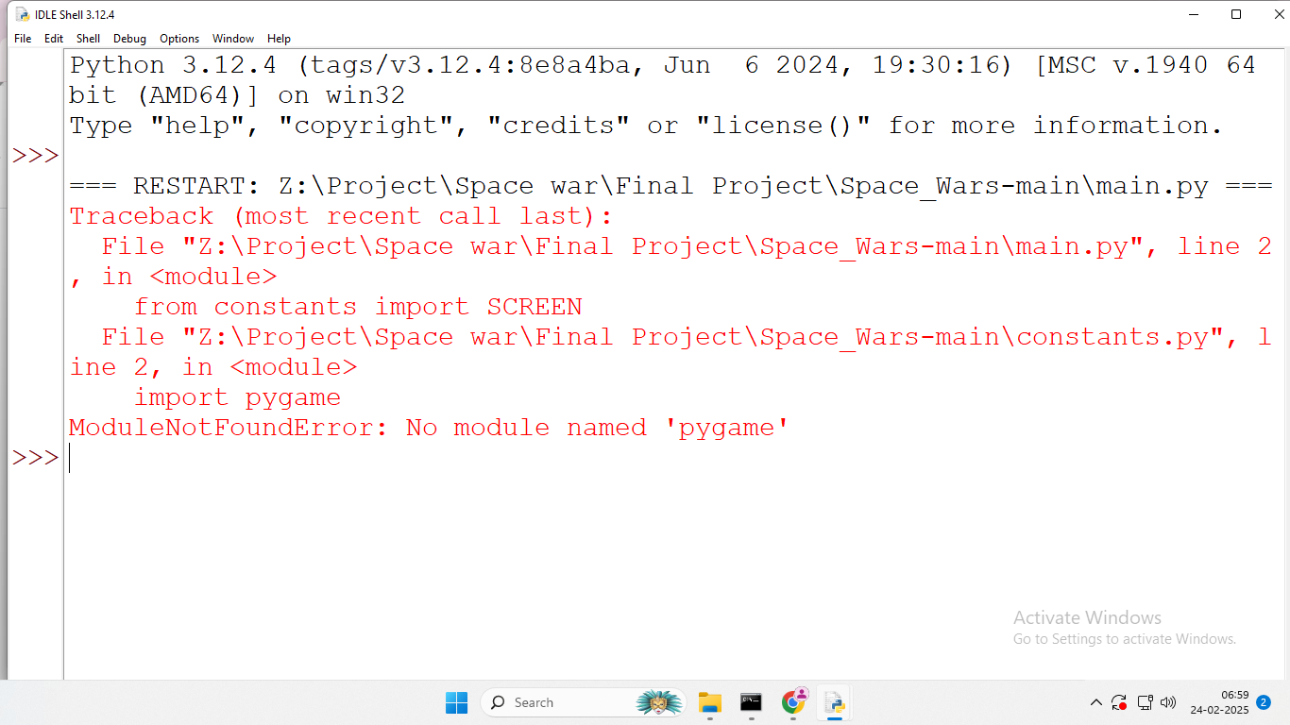

**Solution:** Install Pygame module.

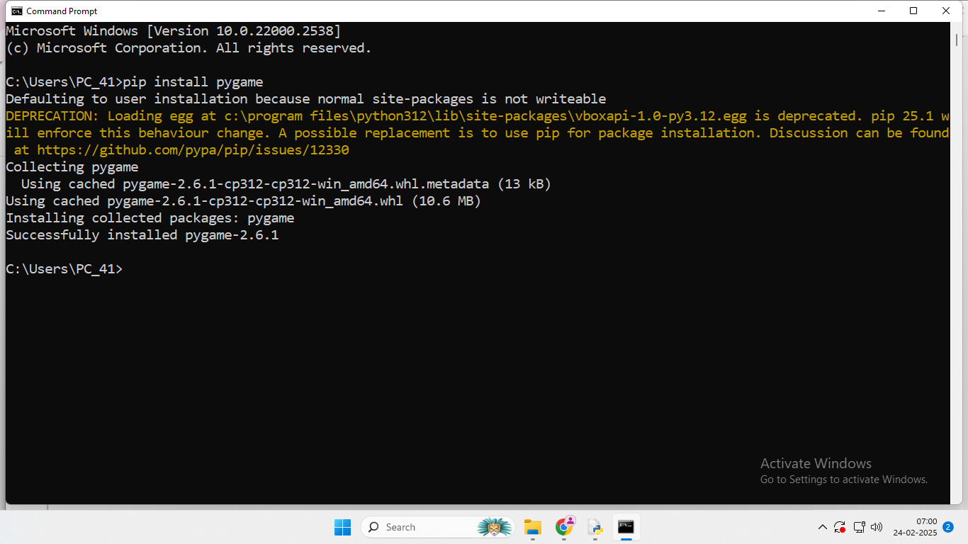

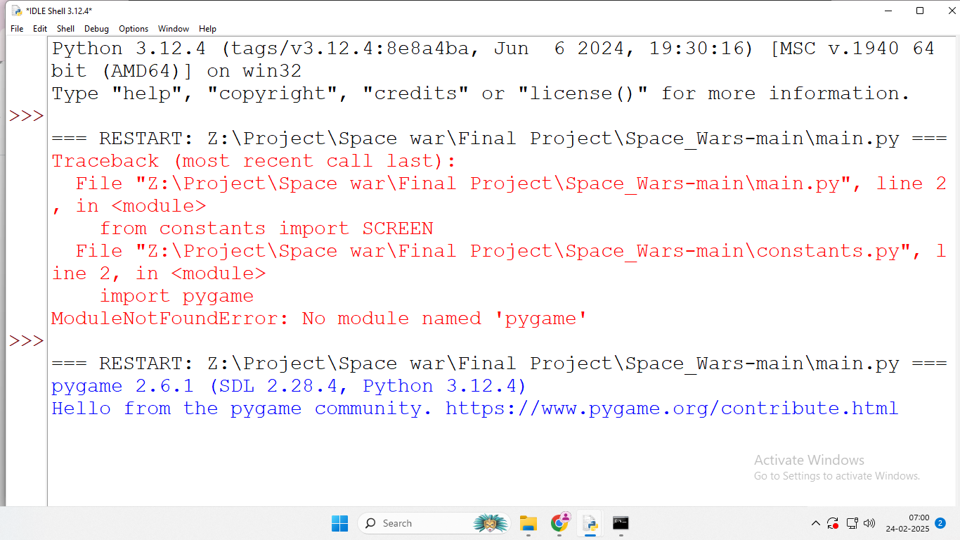

**Error:** pause.py file is not imported as module in main.py.

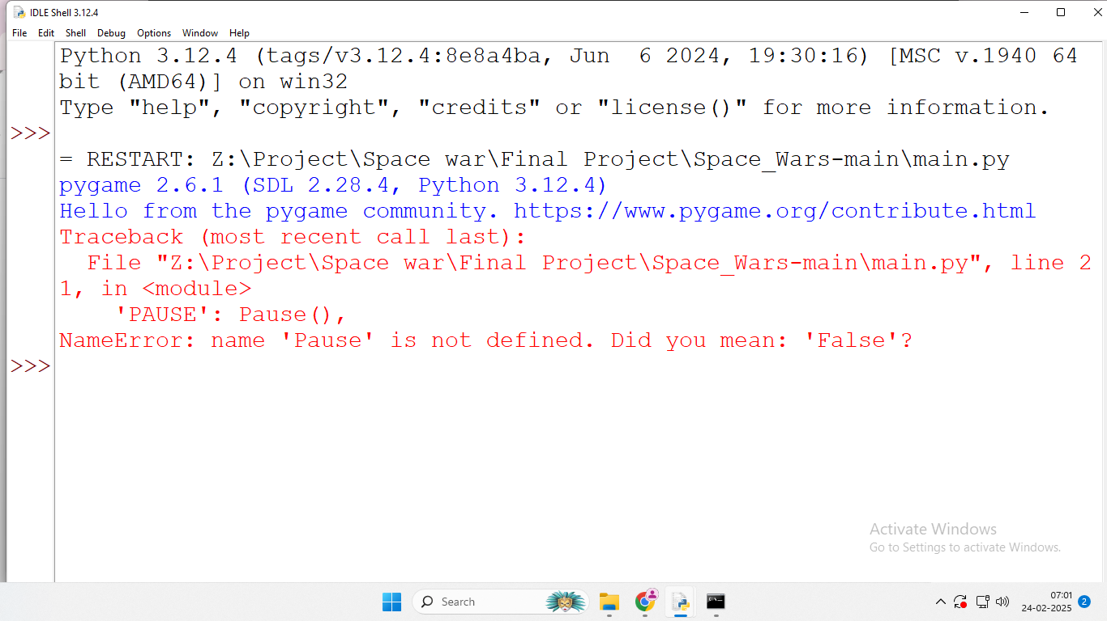

**Solution:** Import pause.py in main.py file.

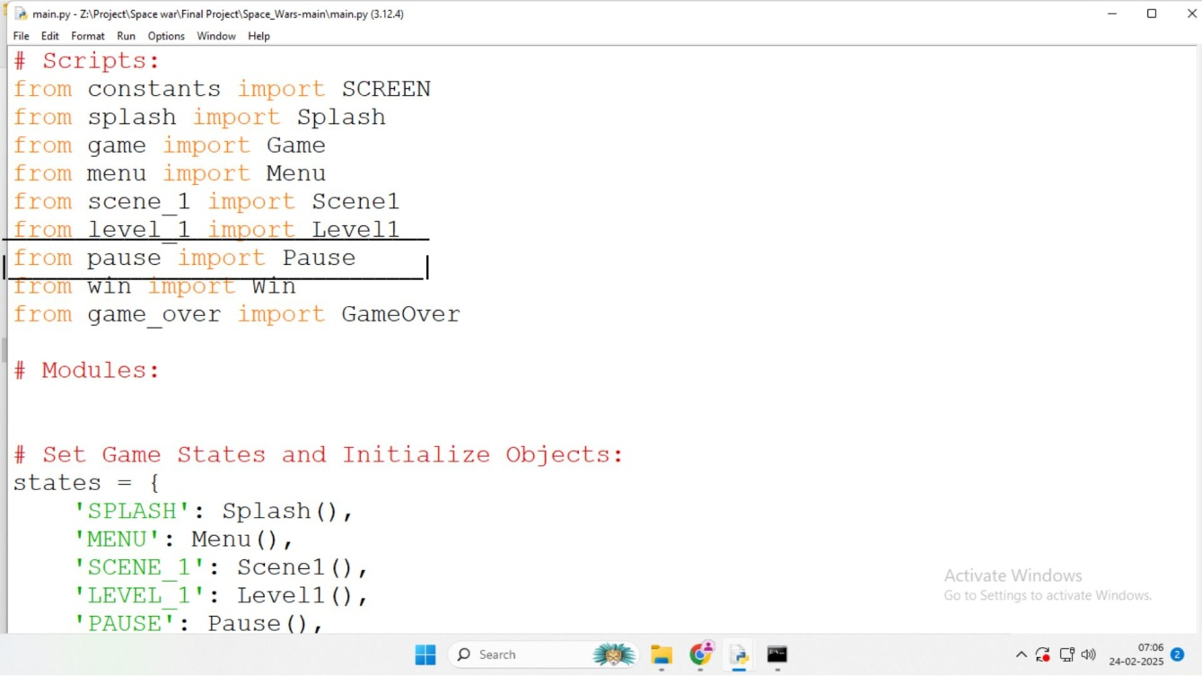

**White box testing**

* White Box testing is based on an analysis of internal working and structure of a piece of software. White box testing is the process of giving the input to the system and checking how the system processes that input to generate the requied output. It is necessary for a tester to have full knowledge of the source code.

**Error:** Because quit() function is not called in menu.py in handle_action() function and get_event() function.

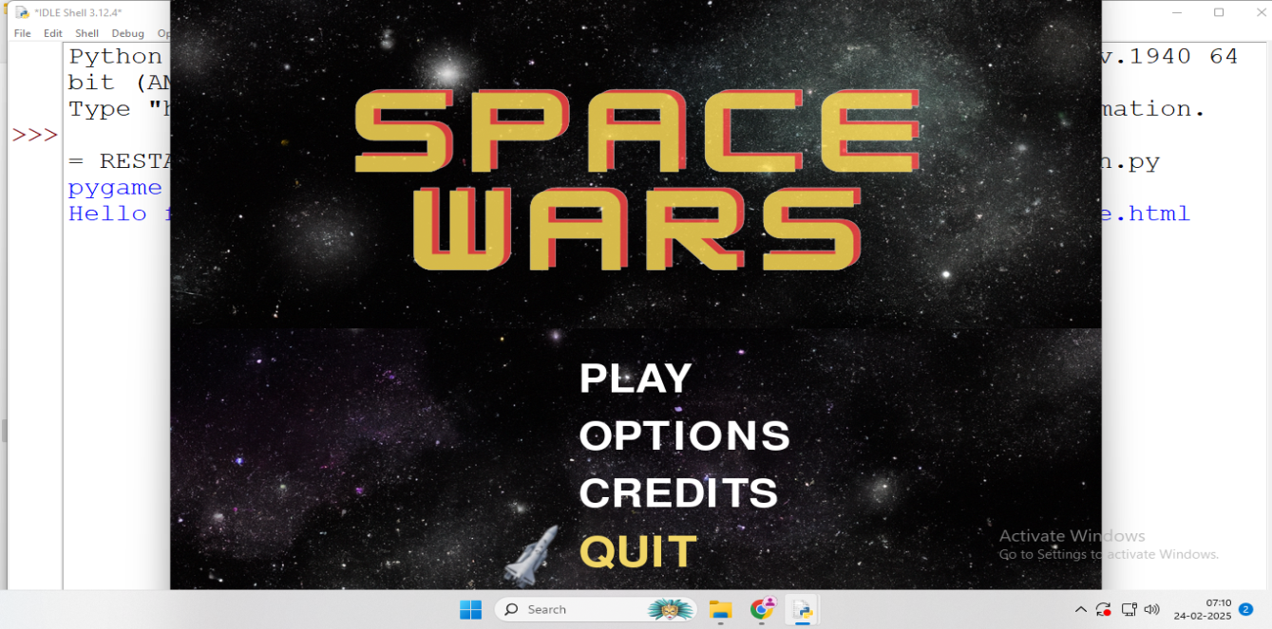

**Solution:** Call quit() function in menu.py in handle_action() function and get_event() function.

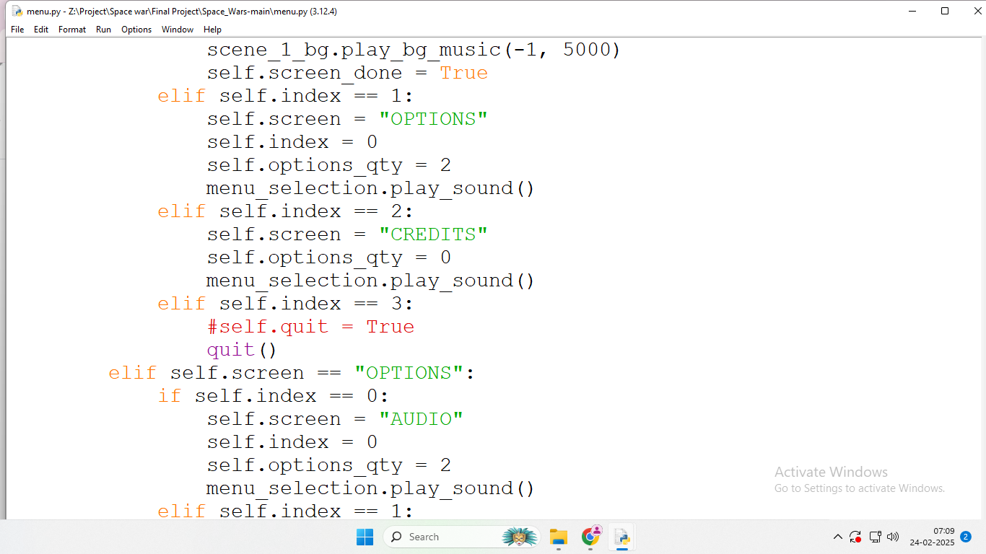

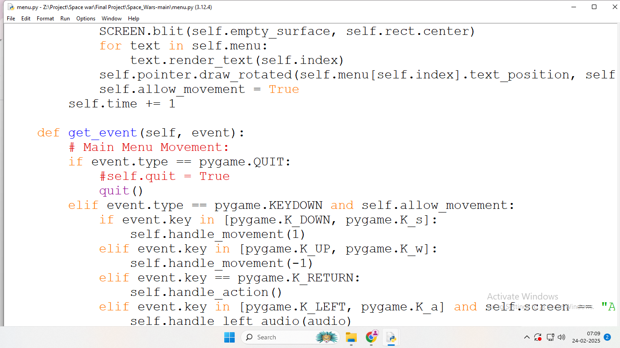

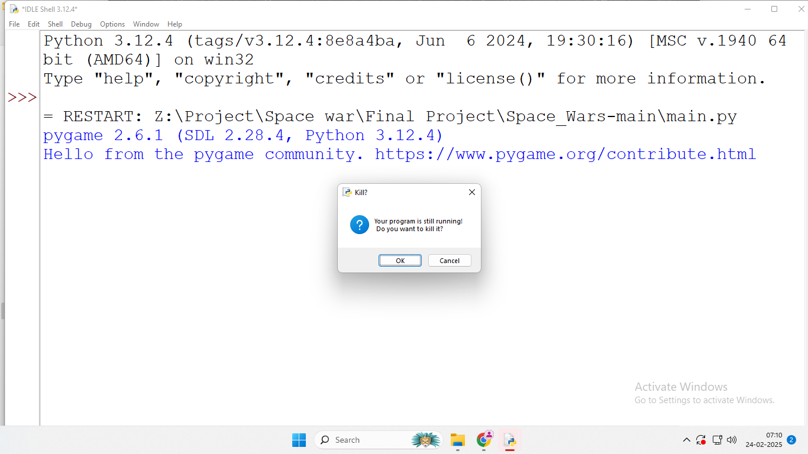

**4. SCREEN SHOTS AND USER MANUAL:**

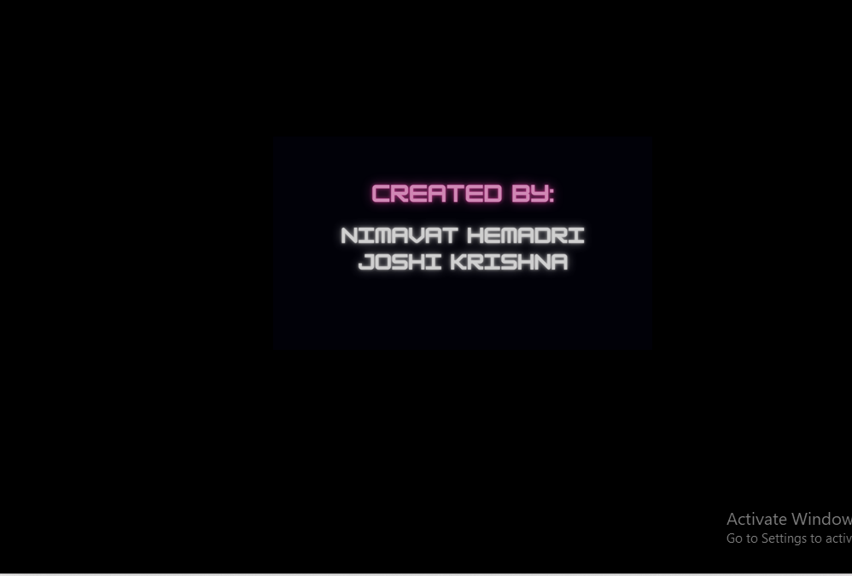

Main Menu

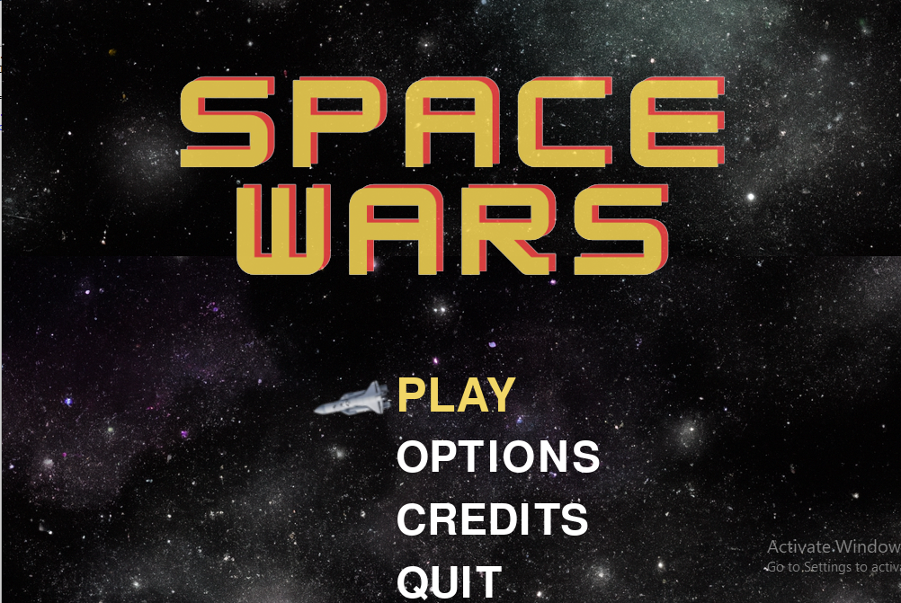

Option Menu

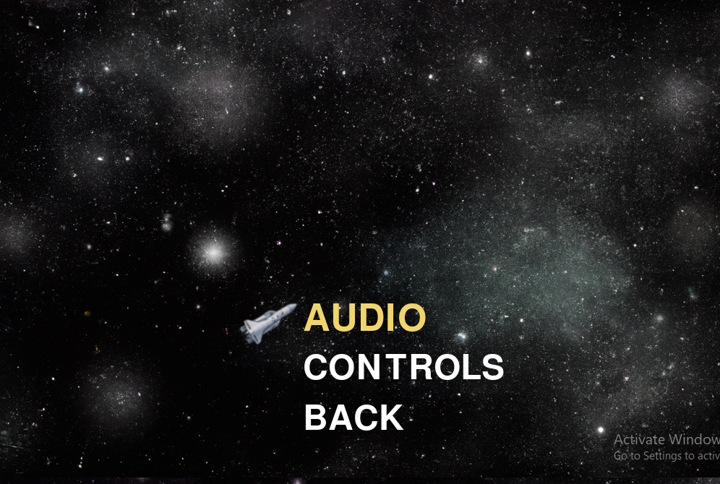

Audio Menu

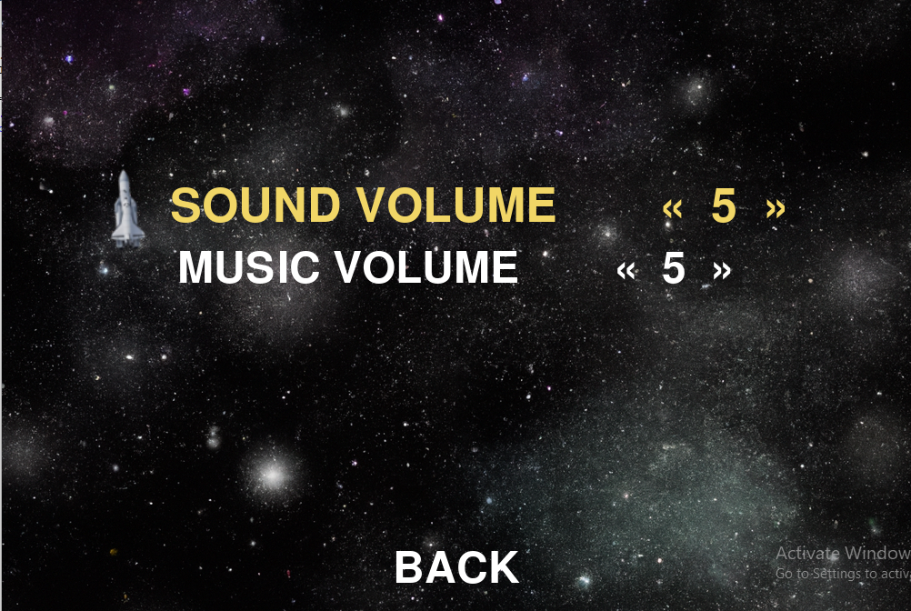

Controls Menu

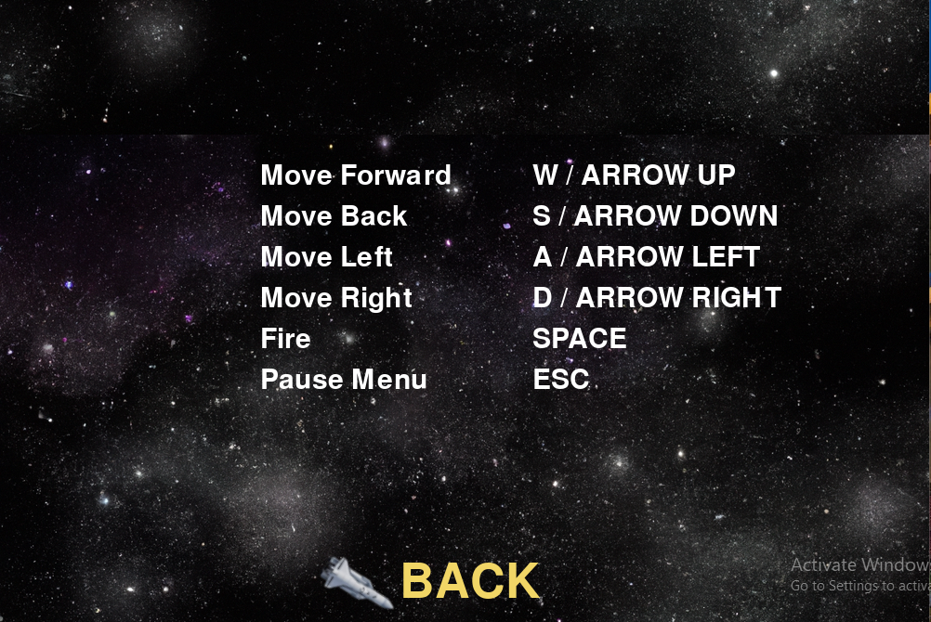

Credits Menu

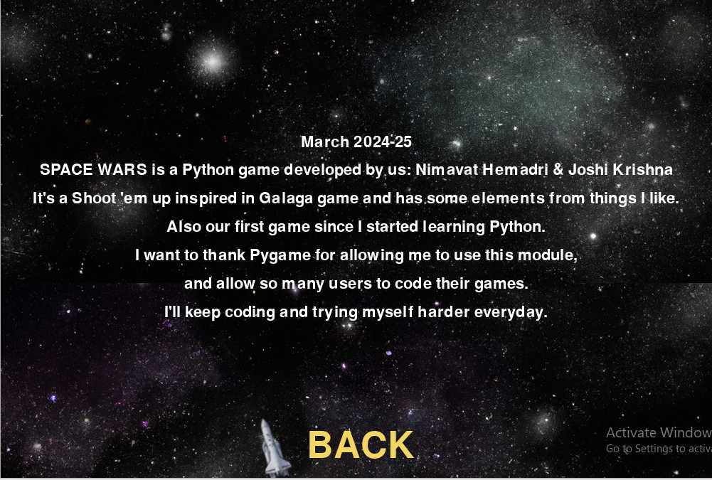

Scene 1

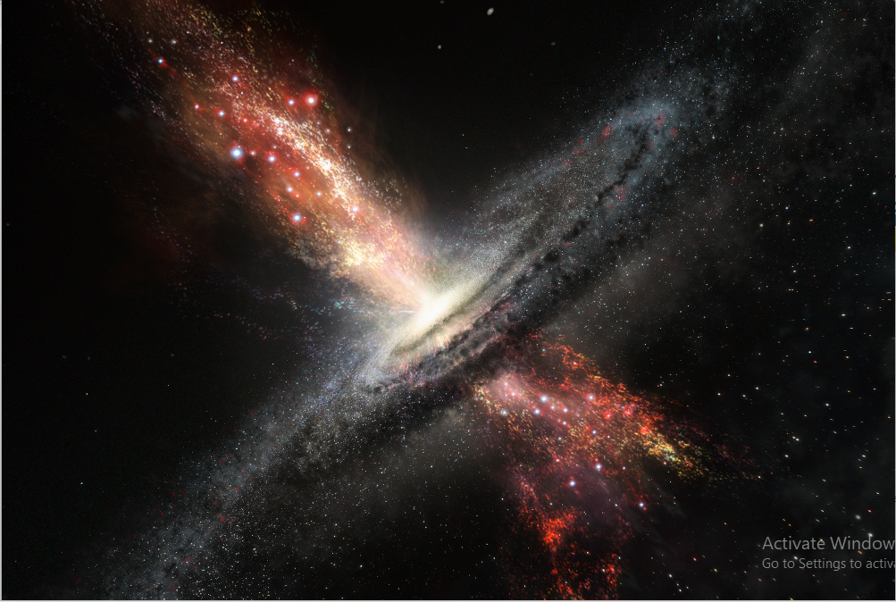

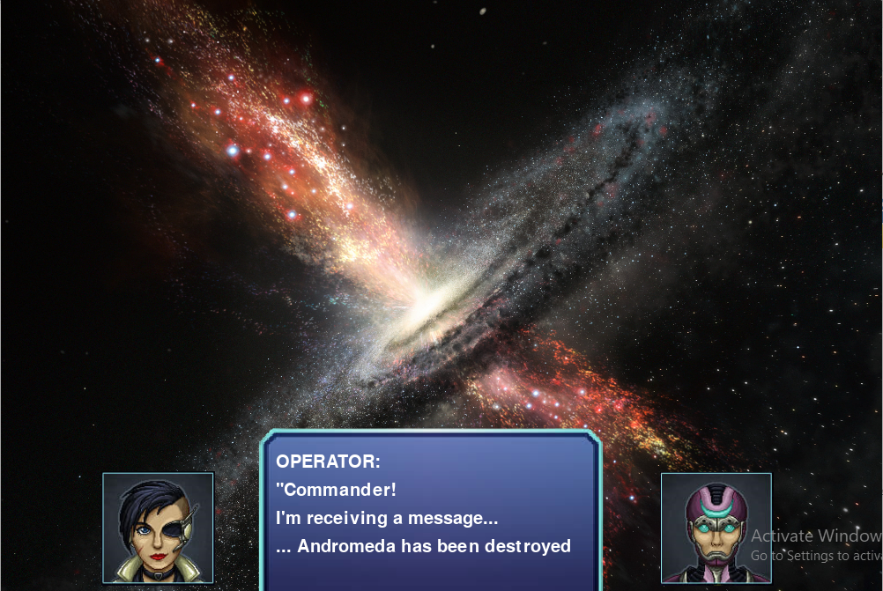

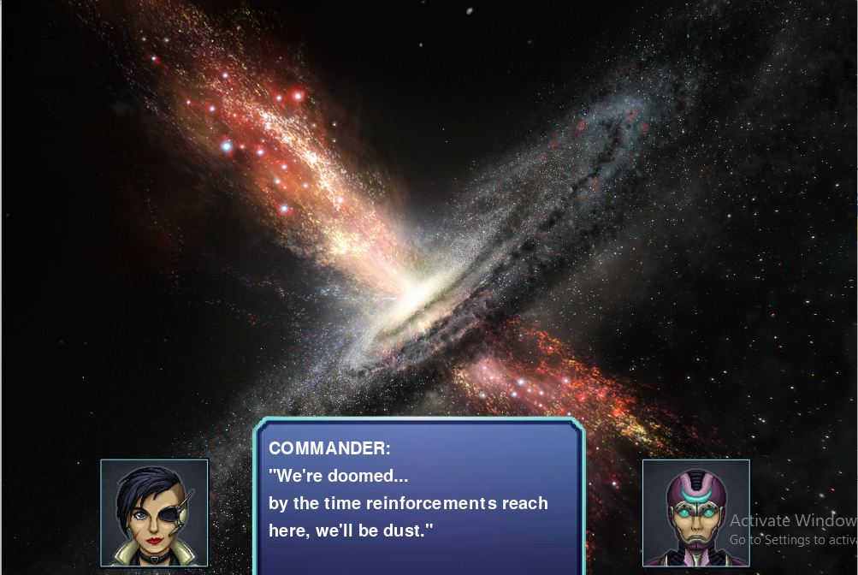

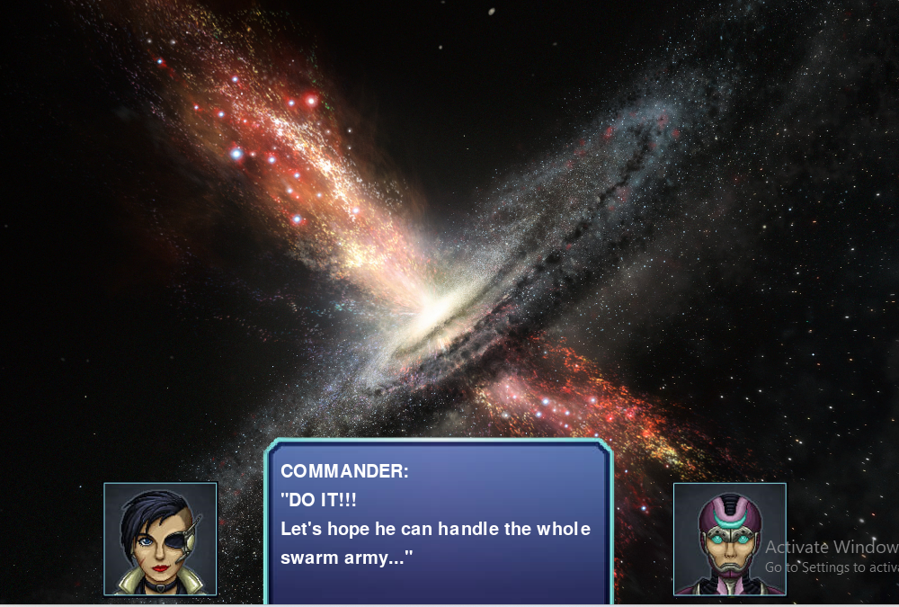

Play Screen

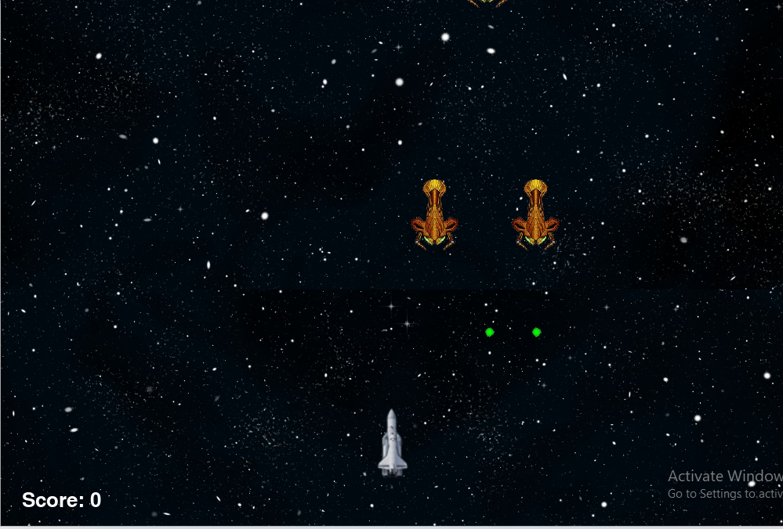

Pause Menu

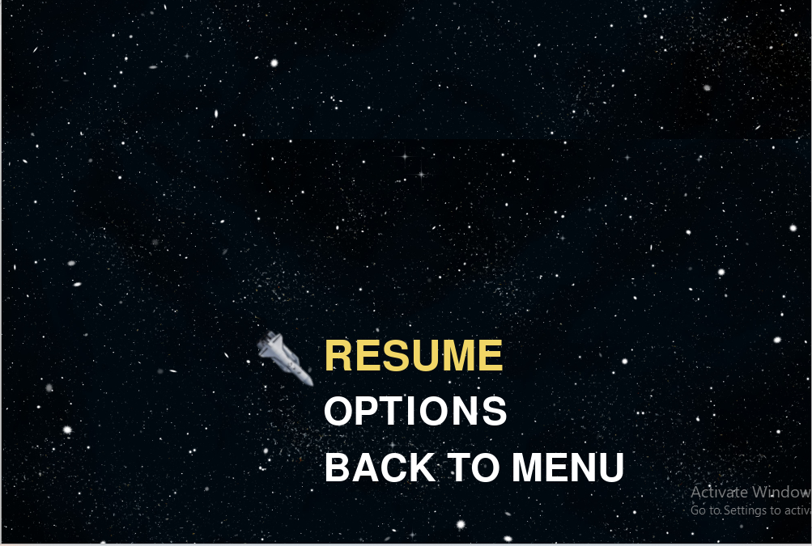

Game Over Screen

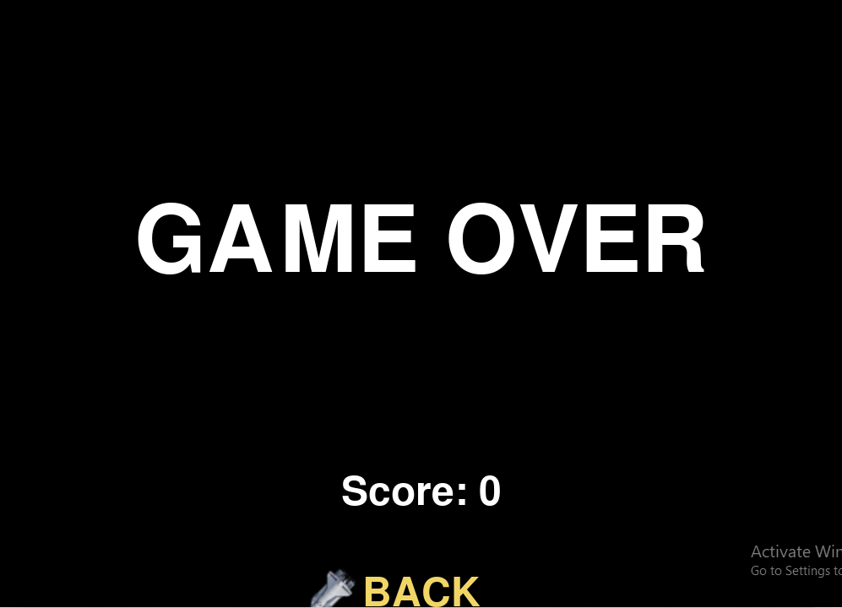

**5. LIMITATION AND FUTURE ENHANCEMENT:**

**LIMITATIONS:**

1. **Technical Constraints:**
   * Real-time Physics Simulation**:** Accurately simulating the physics of space, particularly in real-time, can be computationally intensive and challenging.
   * Procedural Generation**:** While procedural generation can create vast and diverse space environments, it can sometimes lead to repetitive or less interesting areas.
2. **Game play Design Challenges:**
   * Balancing Difficulty**:** Finding the right balance between challenging combat and accessibility can be difficult.
   * Strategic Depth**:** Creating deep and engaging strategic layers without overwhelming players is a delicate task.
   * Player Engagement**:** Maintaining player interest over extended periods can be challenging, especially in single-player modes.
3. **Market Saturation:**
   * The market is already saturated with space-themed games, making it difficult to stand out

**FUTURE ENHANCEMENTS:**

1. **Advanced AI:**
   * Adaptive AI: AI opponents that learn from player behavior and adapt their strategies.
   * Emergent Behavior: AI that exhibits complex and unpredictable behaviors, leading to more dynamic and realistic encounters.
2. **Realistic Space Simulation:**
   * Accurate Physics**:** Implementing more realistic physics simulations, including zero-gravity environments and orbital mechanics.
   * Dynamic Space Environments**:** Creating dynamic space environments with changing weather patterns, celestial events, and realistic lighting effects.
3. **Immersive Experiences:**
   * Virtual Reality (VR**):** Leveraging VR technology to provide fully immersive experiences.
   * Augmented Reality (AR): Integrating AR elements to bring space battles into the real world.
4. **Multiplayer Experiences:**
   * Massive Multiplayer Online (MMO) Games**:** Creating persistent online worlds with thousands of players.
   * Cooperative Multiplayer: Enhancing cooperative game play with shared objectives and strategic planning.
   * Competitive Multiplayer: Introducing balanced and fair competitive modes.
5. **Storytelling and Narrative:**
   * Branching Narratives: Allowing players to shape the story through their choices.
   * Character Development: Creating deep and relatable characters with compelling back stories.

* How to Play
* Use the arrow keys or WASD to control your spaceship's movement.
* Press the spacebar to shoot and destroy the enemy bugs.
* Avoid colliding with enemy bugs or their projectiles to prevent losing health.
* Collect power-ups and upgrades to enhance your firepower and defense (developing...)-Defeat the enemies and achieve the highest score!